THE TITLE OF PAPER

A. Kowalski¹, H. Schmidt²
¹ Institute of Computer Science, Warsaw, Poland, kowalski@ics.waw.pl
² RWTH, Aachen, Germany, schmidt@rwth-aachen.de

1. General
In order to promote discussion at the meeting the Authors are kindly asked to submit extended four page abstracts in English. The aim of such abstract is, firstly, to present the topic considered in the paper and, secondly, to point out the directions of possible bilateral co-operation on this topic. Please, describe briefly the area of interest, basic assumptions and method used and highlight the main results of the paper. A list of basic references is recommended.
Note that this kind of publication serves the above mentioned aims and is by no means a full length paper. After the workshop the Authors of selected papers will be encouraged to submit a full-length paper for the special issue of the Bulletin of the Polish Academy of Sciences. Technical Sciences (http://bulletin.pan.pl/) - a journal published quarterly by the Academy.
The abstracts must reach Dr. Jacek Szklarski (jszklar@ippt.gov.pl), the Secretary of Workshop by April 1, 2009.

2. Formatting issues
Times Roman fonts of 10 point size should be used throughout the body of paper with single spacing between lines of text. Paragraphs opening a new section or following a figure, a table or an equation should not be indented. Other paragraphs should be indented by 1 cm in the first line.
The title should be left aligned in capital 12 point characters and bold face. Do not leave any additional space above the title. The title should be followed by authors’ names (bold, 11 point) and respective affiliations (italic, 10 point, indented by 1 cm). Leave one empty line between the title and the authors’ names and two empty lines between the affiliations (institution, city, country and e-mail) and the beginning of the paper body. In order to save space, the affiliation should not include the full address of your Institution, which will be given in a separate list of participants.
Section headings should be left aligned with no indentation, set in bold 11 point face with extra space of empty line above and 6 points below. Publishing office will convert abstracts into the Tex-based format. Hence, the usage of advanced features of the Word editor (automatic numbering, bookmarks, etc.) is discouraged.

3. Tables, figures and formulae
Figures, tables and their captions should be flushed left and numbered. Leave empty line above and below the figure/table.

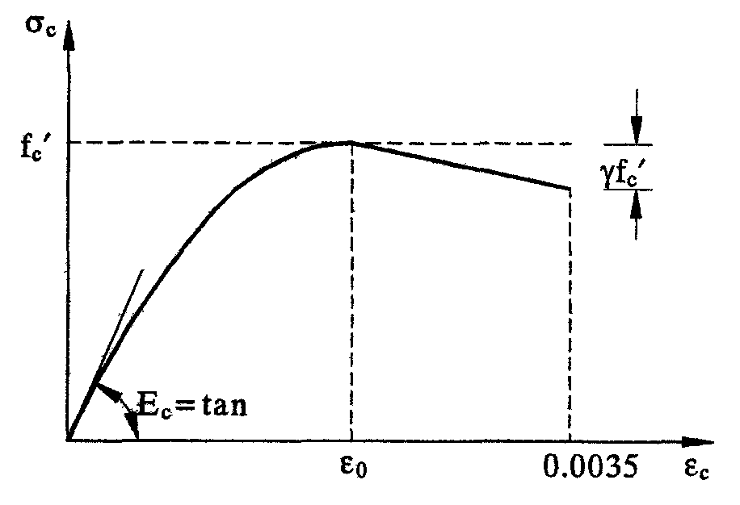
Fig 1. Stress-strain relationship for compressive concrete

Please, avoid grey-scale pictures that may not reproduce correctly. Place captions of tables over them, as shown below.
Table 1. Basic format specifications.
Paper size | Paper length | Font size | Line spacing
A4 (210x297) | 4 pages | 12 pt | single

Displayed equations should be left aligned with 2 cm indentation. Equation numbers (if necessary) should be placed in brackets at the left margin with no indentation, e.g.:
(1) $y=x^{2}+\frac{\text{ln}x}{x}$
Sufficient space (at least 6 pt) should be left above and below the equation.

References
References should be placed at the end of the paper and cited in the paper through a number in square brackets, e.g. [1]. The format of references for a sample book, a journal article and a conference proceedings article is given below.

- M. Bom and E. Wolf, Principles of Optics, Pergamon Press, Oxford 1989.
- K. Sankarasubramanian and P.A. Venkatakrishnan, “CCDbased polarization interferometric technique for testing waveplates”, Optics & Laser Technology 30 (l), 15-21 (1998).
- D.A. Scriber, M.R. Kruer, and J.M. Killiany, “Infrared focal array technology,” Proc. IEEE 79, 66–85 (1991).

